Am,S-Colombia-Tairona-Tumbaga-collection



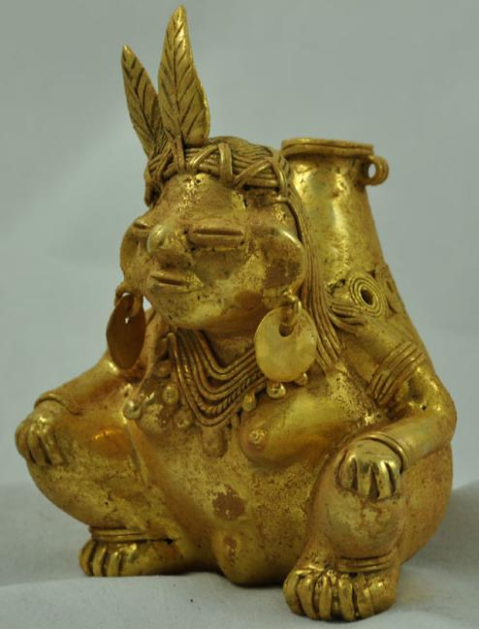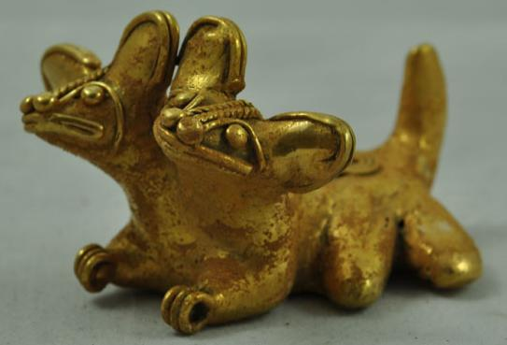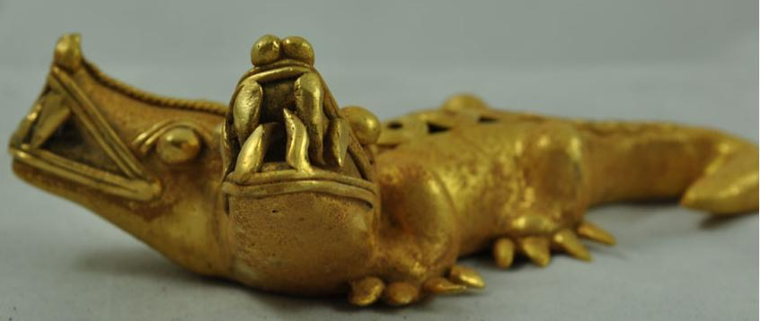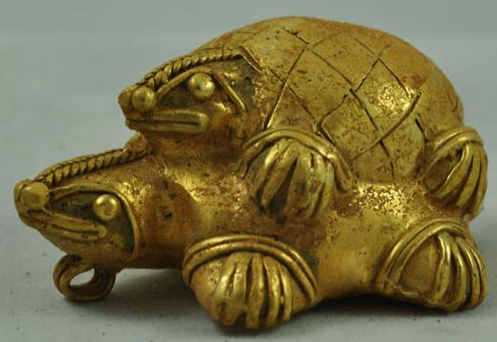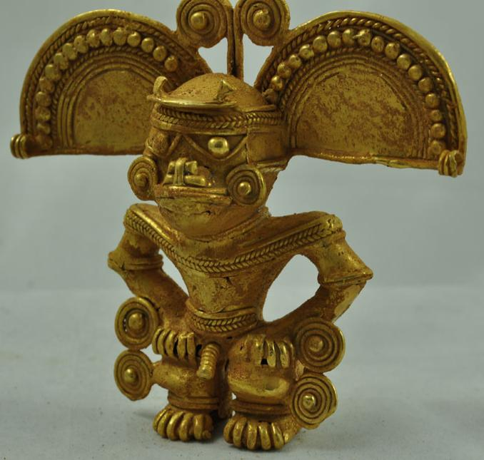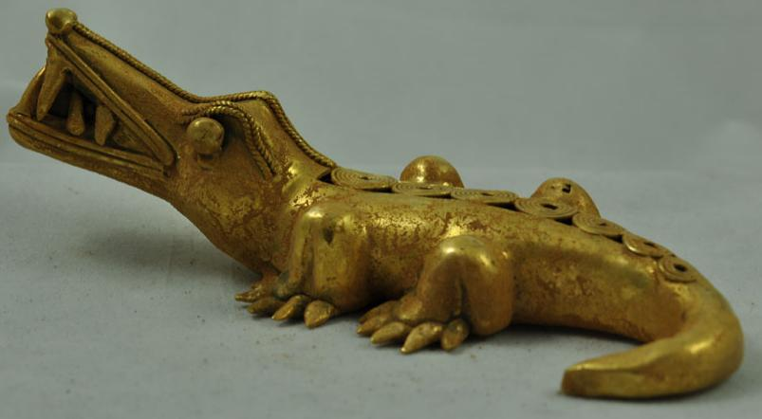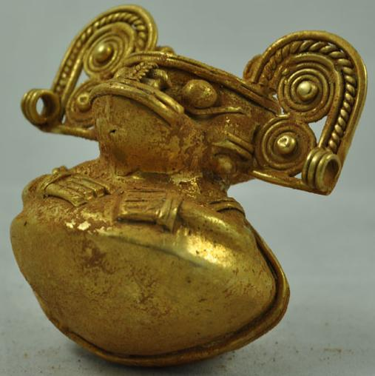

|  |
| --- |
| Payment details |
|  |
|  |
| Shipping details |
| **Ralph J Coffman Jr**  149 Atlantic Ave  Swampscott MA 01907-2427  United States |

## Order details

|  |  |  |  |
| --- | --- | --- | --- |
| **Item title** | **Available actions** | **Shipping & handling (estimated delivery*)** | **Price** |

[Printer version](http://payments.ebay.com/ws/eBayISAPI.dll?ViewPaymentStatus&transid=716610066003&userloginid=802-867&printerversion=true&itemid=130795865105)

|  |  |  |
| --- | --- | --- |
| Seller: | [**Member id** lostantiks](http://myworld.ebay.com/lostantiks) ( [**Feedback Score Of** 428](http://feedback.ebay.com/ws/eBayISAPI.dll?ViewFeedback&userid=lostantiks)) | [Contact seller](http://contact.ebay.com/ws/eBayISAPI.dll?ShowCoreAskSellerQuestion&frm=3998&iid=130795865105&redirect=0&requested=lostantiks) |

|  |  |  |  |  |
| --- | --- | --- | --- | --- |
| Paid on Nov-06-12 via PayPal | | | | |
|  |  |  |  |  |

|  |  |  |  |  |  |  |  |  |
| --- | --- | --- | --- | --- | --- | --- | --- | --- |
|  | [**Item Title:** Rare! Massive Collection x 17! Tairona Tumbaga Columbian! Liquidation!! x 17!!!**- opens in a new window or tab**](http://cgi.ebay.com/ws/eBayISAPI.dll?ViewItem&item=130795865105)  **Item Id:**130795865105 - Price: US $1,699.00  Quantity:1  Having a problem with this purchase? [We can help](javascript:;) | |  | | --- | |  | | |  |  | | --- | --- | | [Leave feedback](http://feedback.ebay.com/ws/eBayISAPI.dll?LeaveFeedbackShow&useridfrom=802-867&useridto=lostantiks&item=130795865105&transactid=716610066003) |  | | | Expedited Shipping: **FREE**  Estimated delivery between Thu. Nov. 08 and Tue. Nov. 13 per eBay FAST 'N FREE | US $1,699.00 |



|  |  |  |  |  |
| --- | --- | --- | --- | --- |
|  | | |  | |
|  |  | |  |  |  |  |  |  |  |  |  |  |  |  |  |  |  |  |  |  |  |  |  |  |  | | --- | --- | --- | --- | --- | --- | --- | --- | --- | --- | --- | --- | --- | --- | --- | --- | --- | --- | --- | --- | --- | --- | --- | | |  | | --- | | |  |  |  |  |  |  |  |  |  |  |  |  |  |  |  |  |  |  | | --- | --- | --- | --- | --- | --- | --- | --- | --- | --- | --- | --- | --- | --- | --- | --- | --- | --- | | Subtotal:   |  |  | | --- | --- | | US $1,699.00 |  | |  | | | Shipping & handling: | FREE | |  | | |  | | |  | | | Total: | US $1,699.00 | |  | | | | |  |  | | | | |  |